**Grove – Collision Sensor**

窗体顶端

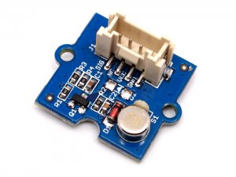

http://www.seeedstudio.com/depot/includes/templates/pure_green/images/next_l.gif

* [http://www.seeedstudio.com/depot/bmz_cache/9/9d565cc14a6354a701dbc4578703e8b6.image.55x41.jpg](http://www.seeedstudio.com/depot/images/product/P3282726.jpg)
* [http://www.seeedstudio.com/depot/bmz_cache/9/93519e2b497db63b74e5d4a47a806835.image.55x41.jpg](http://www.seeedstudio.com/depot/images/product/P3282726_01.jpg)

http://www.seeedstudio.com/depot/includes/templates/pure_green/images/next_r.gif

* **Price:**

$8.30  [(Price Feedback)](javascript:void())

* **SKU:**

SEN03281P

* **Weight:**

3Gram

* **Units in Stock**

0

* **Designed by:**

[Seeed Studio](http://www.seeedstudio.com/)



[Other products from designer](http://www.seeedstudio.com/depot/seeed-studio-m-23.html)

* Sold Out [Notify Me](http://www.seeedstudio.com/depot/grove-collision-sensor-p-1132.html?cPath=144#back_in_stock_notification_form)
* [Add to Wish List](http://www.seeedstudio.com/depot/index.php?main_page=un_wishlist&products_id=1132&cPath=144&action=un_add_wishlist)

Description

Have you ever been bothered for detecting simple collisions with complex algorithm with an acceleration sensor? The collision sensor is here to simplify the process,. It's also omni directional, stable, and sensitive.

**Features**

* Wide power supply range DC3.3V to 5V
* Grove module
* High sensitive
* RoHS/WEEE lead-free compliant

**Documents**

Please visit our [wiki](http://www.seeedstudio.com/wiki/Grove_-_Collision_Sensor) page for more info about this product. It will be appreciated if you can help us improve the documents, add more demo code or tutorials. For technical support, please post your questions to our[forum](http://forum.seeedstudio.com/).

窗体底端